# Specificity in CSS –

Cascade algorithm **-** This algo determines which property will be applied in case of conflicting properties

1. Position and order of apperance - koi property baad mein likhi hogi to wo hi apply hogi. agar value same h to.
2. Specificity - which selector is more specific



Inline is most specific, agar inline declared h to guru mantra manajayega

**\*What are attribute selectors - for them we put like, if data="a"**

**and in the style tag we put them like:**

**[data=a]{**

**color: pink**

**}**

**They are not put in class**

**Golden rule is to use least specific selector – because it is easier to overwrite**

1. Origin – The order in which CSS appears and where it comes from. Like whether it is browser CSS or your origin CSS. It you don’t mention any style yourself for a particular element then browser puts some style on it by default called user agent style sheet

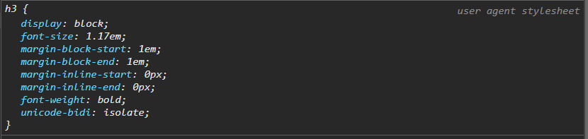

1. Some CSS rules are given more weightage then others. Like if you use !important rule , and will override inline styles too

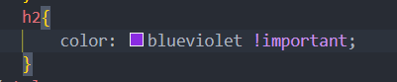

## Specificity calculation

Give points to each type of class style:

1. Universal selector: 0
2. Element selector and pseudo-selector:1
3. Class selectors, attribute selector and pseudo classes: 10
4. ID selector: 100
5. Inline styles: 1000
6. !important: 10000

If the types of selectors are bundled together like: element selector + class selector

Then their specificity is added so for 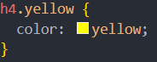 the total becomes 11.

then 

here yellow will dominate.

Question: Calculate specificity value

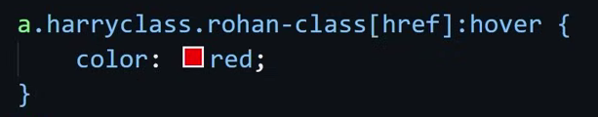

Ans: 41

a = 1, harryclass (class attribute) =10, rohan-class (class)=10,

[href] (attribute selector) =10, (this is special type of attribute selector, usually they are like [data=a], that means they will apply when data = a, but here it means that it will apply when [href] exists)

:hover (pseudo class) =10